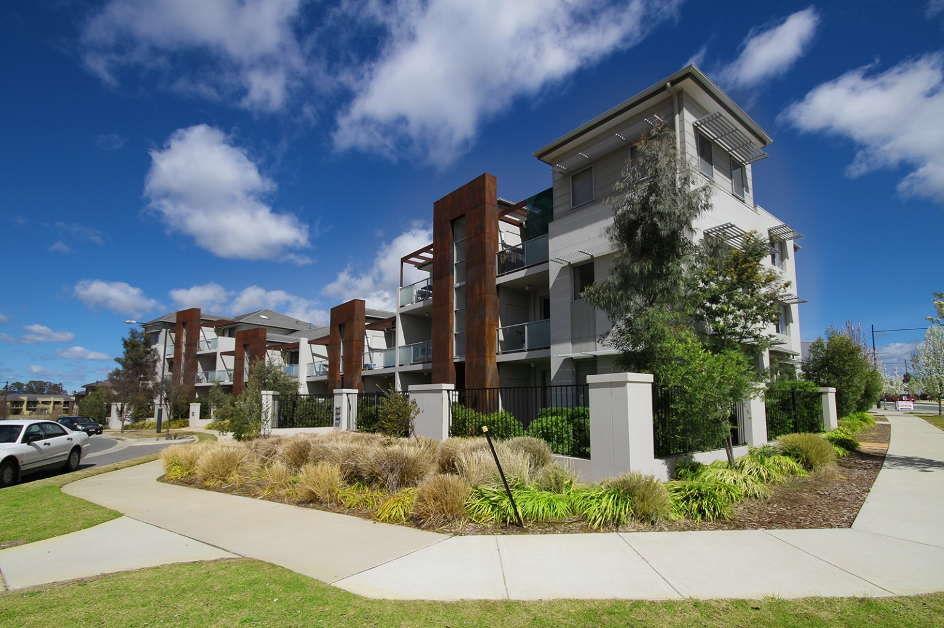
Maintenance Officer
Full time – 38 hours per week
Closing Date: Friday, 6 January 2023

Thank you
For your interest in the position of Maintenance Officer with CHC. This selection pack will provide you with all the information you will need to complete your application by the 6 January deadline.
What Will I Be Doing?
CHC is seeking a highly motivated and organised person to effectively maintain CHC properties through both planned and unplanned maintenance in accordance with the CHC Asset Management Strategy and budget. As a member of a small team, you will complete urgent, non-urgent and planned maintenance for CHC properties as directed.
Who Are We?
We are a Tier 1 registered Community Housing Provider, with over 20 years’ experience delivering for the Canberra community.

In this time we have undertaken an impressive portfolio of property developments, that has enabled us to be financially independent, and self-fund the delivery of additional community housing supply, and core services including tenancy management, property management, client services, community development and affordable home ownership.
CHC Offering
As a Maintenance Officer (CHC 2) you will be covered by the CHC Enterprise Agreement 2021 – 2025 and entitled to an initial salary of $60,733.00 plus 10.5% Superannuation pa. In addition, Salary Packaging available to staff based on our Public Benevolent Institution (PBI) status currently up to $15,900.00 pa.
CHC offers a family-friendly workplace dedicated to social awareness and responsibility. Ongoing training where individuals are encouraged to better themselves, their workplace and their community. The following benefits are available to all CHC employees:
- Free parking
- Health & Wellbeing Program

Please note: All positions within CHC are subject to probity checks that could include a Police Records Check and/or a Working with Vulnerable People and Working with Children check.

It is also a requirement that all CHC staff hold a current Driver’s licence.
How Do I Apply?
If you think this is the opportunity for you, please submit your application by completing the application cover sheet found in this pack, providing a statement of claims, not exceeding 1000 words and a copy of your resume. The information you provide will assist us to determine whether your skills, knowledge and experience are the right fit for the position, so be accurate, succinct and show a clear connection with the competencies for this role. There is no requirement to address each competency separately.
Completed applications should be forwarded to careers@chcaustralia.com.au. If you have any questions regarding the selection process please contact Fiona Dearden on 02 6183 4383 or via email at fiona@chcaustralia.com.au. Further information regarding the specifics of the role can be obtained by contacting Kelsey Hindle, Manager Assets on 02 6248 7716 or via email at kelsey@chcaustralia.com.au.

Applications Close: 5.00 pm, 6 January 2023

Application Cover Sheet

Position Applied for: Maintenance Officer
Classification: CHC2 | Salary: $60,733.00 pa + Superannuation

Applicant Details:
Given name: |  | Family name:
Street address:

Postal address:
Home Ph: | Work Ph: |  |  | Mobile Ph:
E-mail:
Do you have a disability that may require reasonable adjustments to our process should you be successful in progressing to interview? |  |  | YES / NO  If yes please we will talk to you prior to interview to arrange.
Are you an Australian citizen or
have the status of permanent resident in Australia?
Referee 1:  Name:  Title:  Relationship to Applicant:  Contact Details:  Mobile:  Work:  Email:  Length of Working Relationship:: |  |  | Referee 2:  Name:  Title:  Relationship to Applicant:  Contact Details:  Mobile:  Work:  Email:  Length of Working Relationship:
Where did you hear about the role? (SEEK, Ethicaljobs, a friend etc)


POSITION DESCRIPTION
Maintenance Officer – CHC 2

Position Status | Full-Time, 38 hours | Reports to / Business Unit | Assets Manager, Operations
Duties:
As a Maintenance Officer you duties will include , but are not limited to:
- Complete urgent, non-urgent and planned maintenance for CHC properties as directed.
- Complete property reviews as per the asset management plan and any additional inspections of all properties (i.e. pre-vacate) as required.
- Liaise with suppliers and tenants regarding maintenance issues.
- Monitor contractors’ performance on an ongoing basis against CHC contractor requirements.
- Maintain appropriate asset maintenance records, including entering contact logs and work orders within CHC Systems.
- Undertake other duties as directed.
Aptitude/Experience:
- Experience in maintaining and repairing houses, apartments and gardens.
- Handyman/ maintenance experience.
- Understanding of the Work Health and Safety issues involved in maintenance work and manual handling in the building industry.
- The ability to liaise with and coordinate external maintenance and service providers to prioritise and manage a variety of completing projects/tasks.
- Hold a current Driver’s Licence. (Essential)

Working Relationships:
- Demonstrated ability to work as an effective member of a small team.
- An understanding of and ability to work with culturally diverse customers.

Communication:
- Demonstrated written and oral communication and the ability to communicate with external parties, tenants and at all levels within CHC.

Organisational Skills:
- Ability to monitor and prioritise allocated tasks.
- Demonstrated ability to produce quality work with attention to detail within defined deadlines.

Values & Behaviours:
- Demonstrated ability to undertake assigned duties, while consistently displaying work practices that are aligned to CHC’s Code of Conduct, Values and Behaviours.
The Position Description does not intend to capture all an individual’s responsibilities but rather to outline the key areas of responsibility.

