Easter Colouring Competition
CHC and HomeGround Real Estate Canberra would like to invite your children to participate in the 2023 Colouring Competition, celebrating Easter.

How does it work?
There will be three competition categories open for entry and each category will use a different colouring sheet. Please, pay attention to which colouring sheet corresponds to your child’s age, as follows:
Category (age group) | Colouring In Sheet
2 to 4 years old | Sheet 1 (2 - 4 years)
5 to 8 years old | Sheet 2 (5 - 8 years)
9 to 12 years old | Sheet 3 (9 - 12 years)

If your children would like to participate, please:
- Fill out this application form.
- Print the colouring sheet accordingly to your child’s age group.
Please contact Emma Cameron (Community Development Manager) on 02 6248 7716 or email events@chcaustralia.com.au if you’d like to collect a printed form and colouring sheet for your child from CHC’s Office (224/29 Braybrooke Street, Bruce).
- Take a picture of their artwork and send it to events@chcaustralia.com.au

Prize: 1 (one) x $ 50 movie voucher to each winner
Winners: Prizes will be awarded to the 1st, 2nd and 3rd places of each category (3 winners per category)
Competition Opens: 9 am, Tuesday, 28th March 2023
Competition Closes: 5 pm, Tuesday, 11th of April 2023
Winners will be notified by Friday 14th April 2023
The collection of prizes will be at CHC Office 224/29 Braybrooke Street, Bruce ACT 2617

TERMS AND CONDITIONS:

- Only one entry per child will be accepted.
- Participants must be between the ages of 2 and 12 years old.
- Participants must enter the correct age category with the corresponding colouring sheet.
- Participants must be dependent(s) of current CHC or HomeGround Affordable tenants.
- All entries must have one registration form and one photo of the coloured drawing submitted.
- The prizes are not transferrable and cannot be taken as cash.
- CHC will not consider entries that are received late.
REGISTER YOUR INTEREST

REGISTRATION FORM (ONE ENTRY PER CHILD)
Tenant details

Tenant name
Child’s name
Child DOB Current age
Tenant email
Tenant address
Photo Consent
To be eligible to participate in this training opportunity, you must:
- be a child of a CHC tenant in the household (ages 5-12 years)
- provide a photo/drawing and completed registration form to enter the competition.
- Sign the photo consent
Tenant Acknowledgement

I provide consent for CHC to record my child’s competition entry (photograph or drawing) for promotional purposes. I understand my entry may be used in mediums including social media, publications and promotional material, print and electronic.
Declaration

By signing the below declaration, you are confirming that the details you have listed are correct and you agree to the Tenant Acknowledgment, Terms and conditions and Photo Consent.

Signature Date
Please complete and return via email to events@chcaustralia.com.au by no later than 5pm on Tuesday, 11th of April 2023. Thank you!

Sheet 1 (2 - 4 years old)

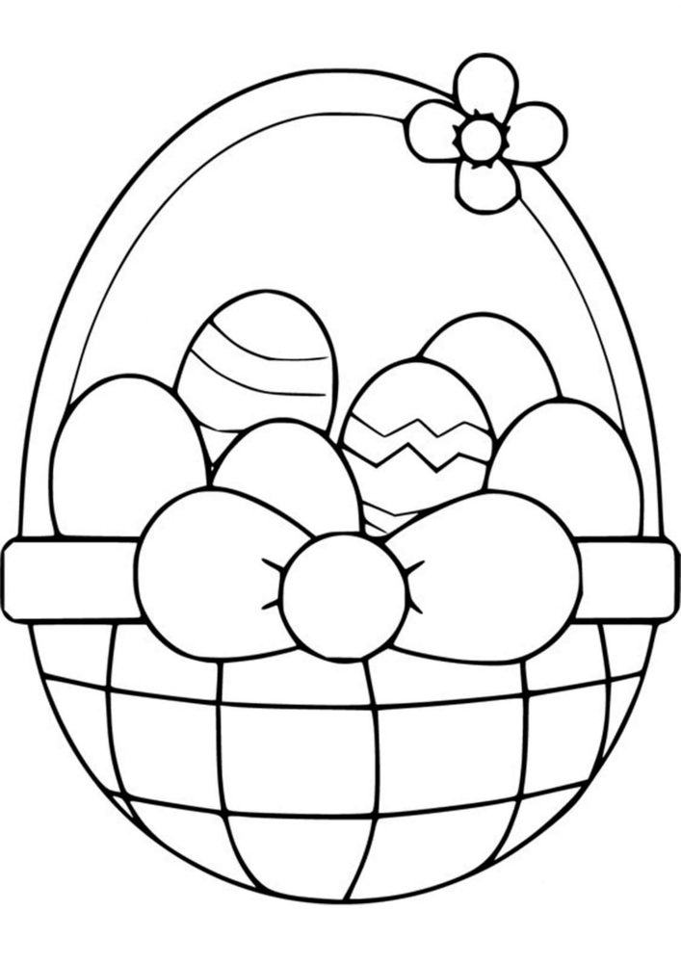

Sheet 2 (5 - 8 years old)

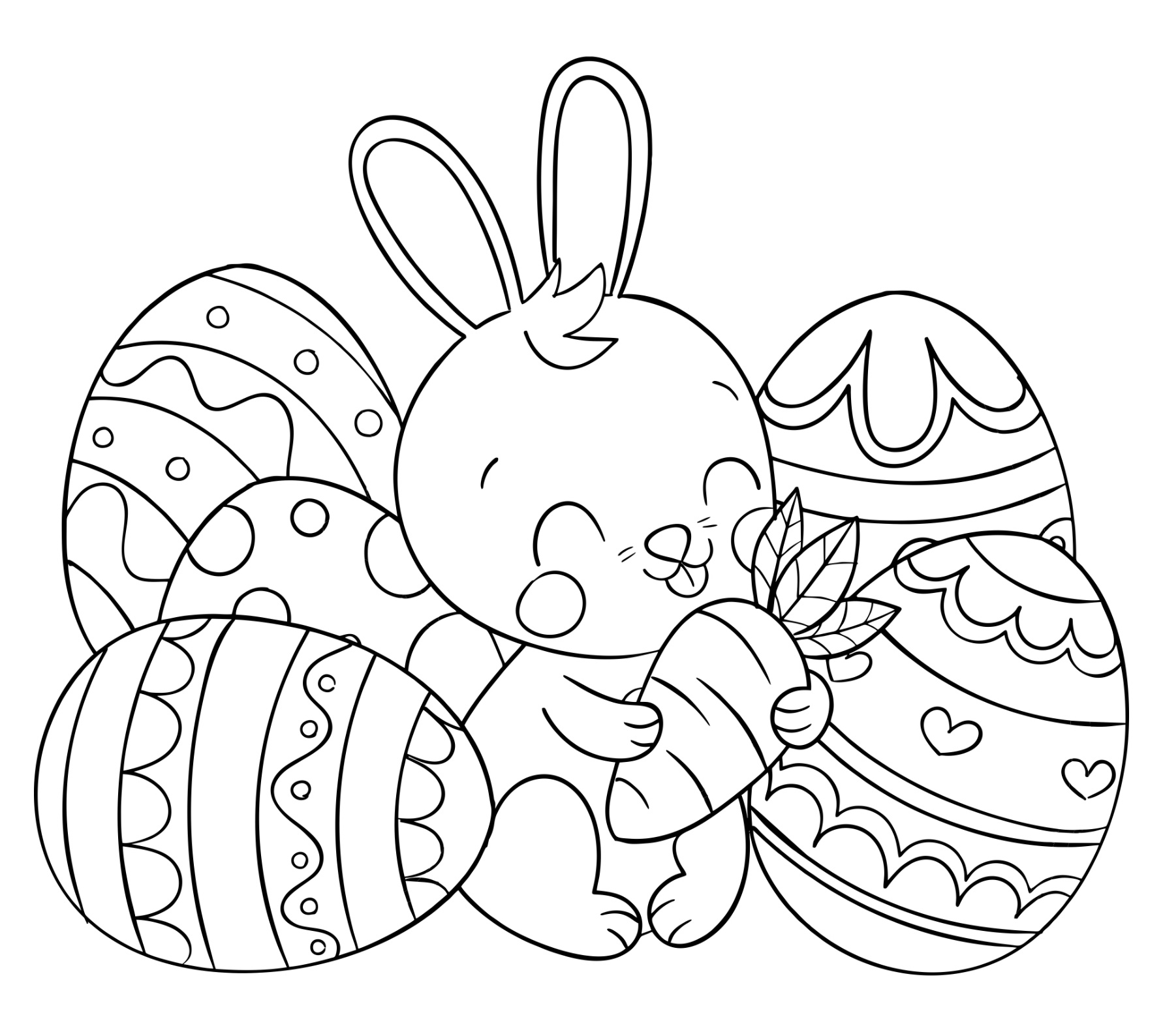

Sheet 3 (9 - 12 years old)

